**Lab 2 Run Map Reduce Java Program on Ubuntu**

**Part 1: Compile WordCount.java**

Step 1: download or write a .java file in your home directory and name it “WordCount.java”. Then type the common:

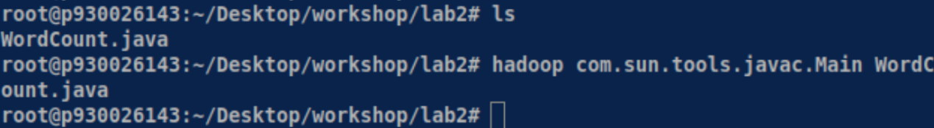

If you get an error, you should check your bashrc file in the HOME path.

Check if it is set correctly. Make sure it has the following four lines:

（The yellow part depends on where you install your Hadoop and java）

-3-3.0

After you finish it, you can type this common to validate the bashrc file.

And run the common again:



You can find that there are three more .class files in the folder:

Step 2: Create a jar

Type the following command: You will find wc.jar is created if everything is fine.

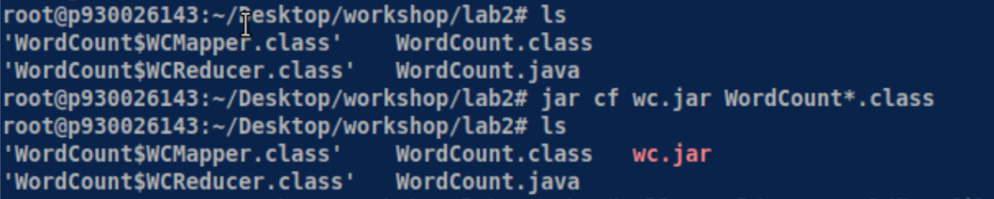

Step 3: create two text files for wordcount program.

We can use Linux redirect feature to create two text files. You can also use vim to create two text files, for example:



Step 4: Start Hadoop system

$ start-dfs.sh

$ start-yarn.sh

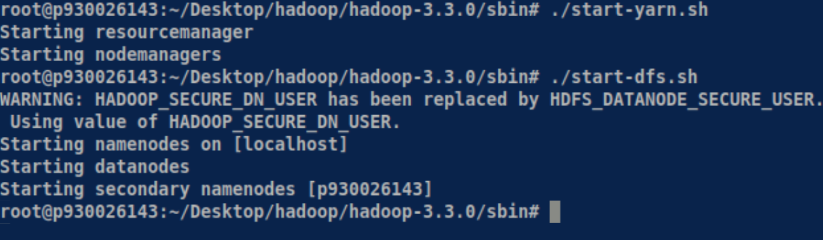

Step 5: Create an input directory

-3-3.0

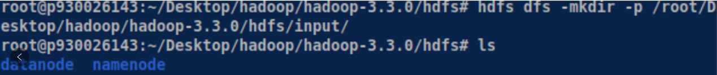

Step 6: Create a wordcount subdirectory under input



Step 7: Upload file01 and file02 from home directory to hdfs directory:

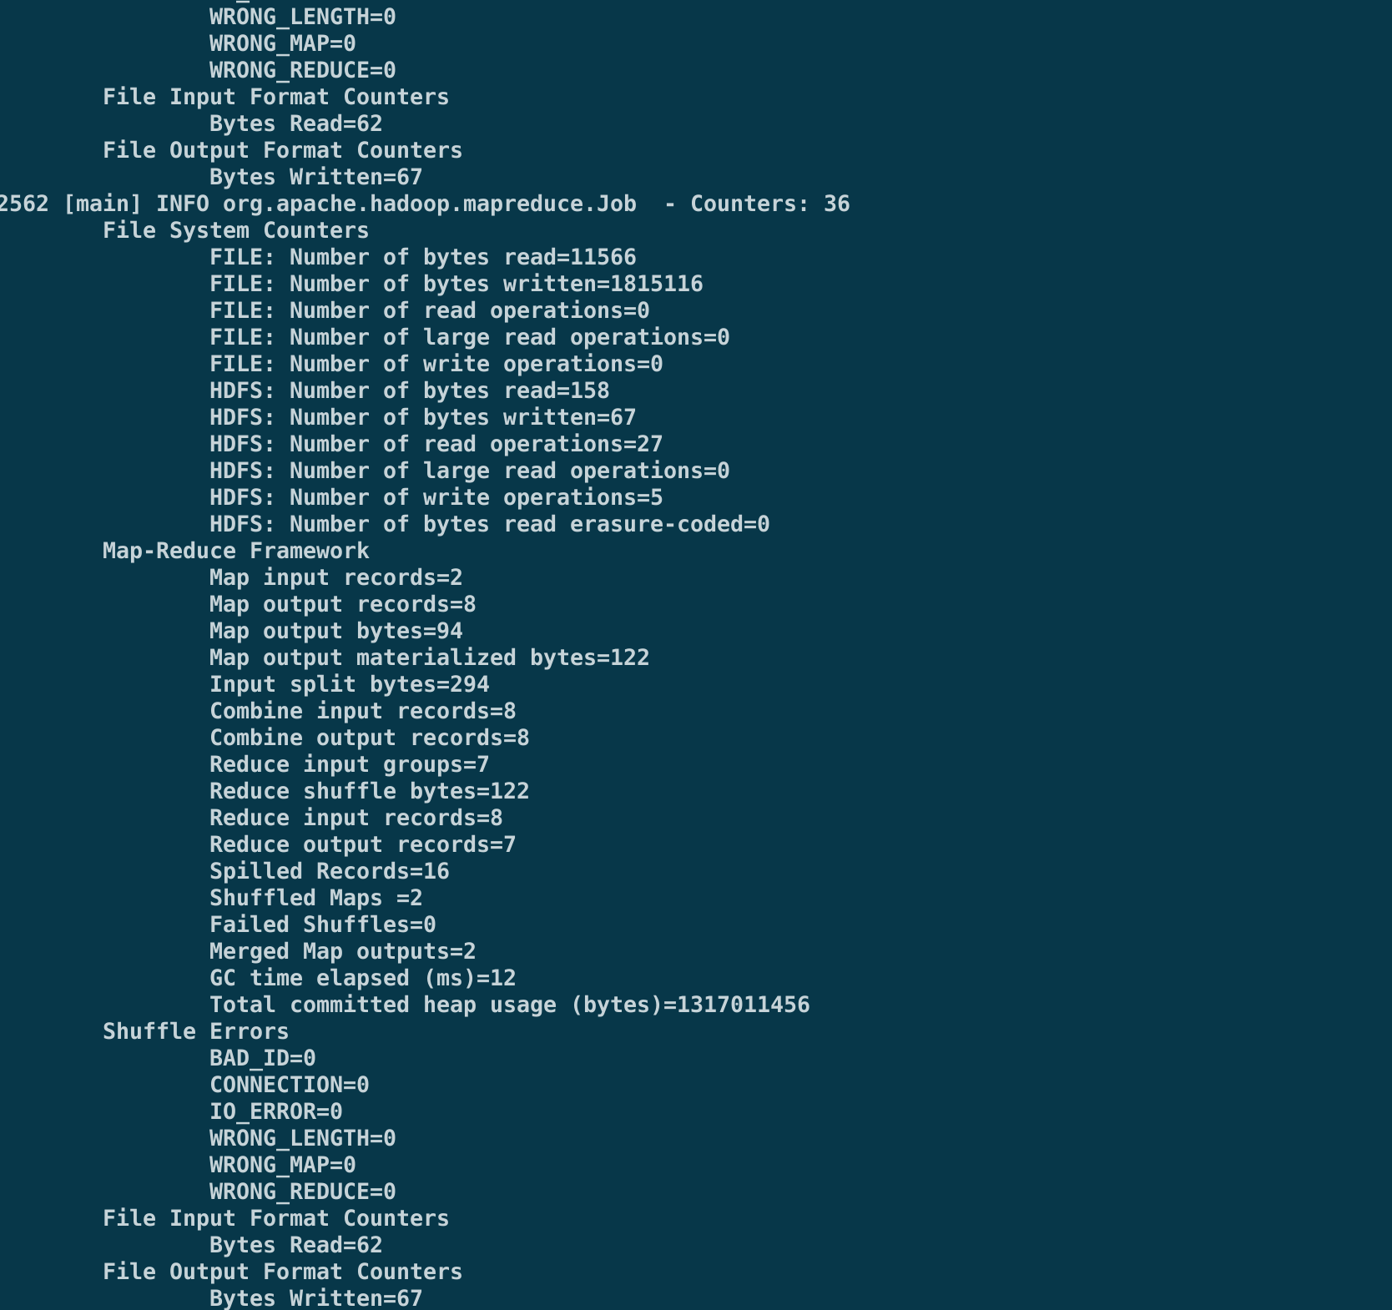

It will get a long message and you should wait about half minutes and the end with the message above the picture.

(If you are unfortunate getting the error messages, you should delete your datanodes and create a new one and repeat the steps from step1 to here)

Then you can check the content of file01 and file02

$ -3-3.0

$ -3-3.0/

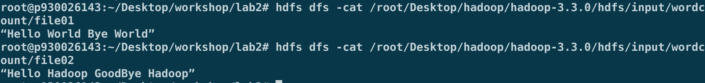

Step 8: Run the application

hadop-3-3.0

-3-3.0

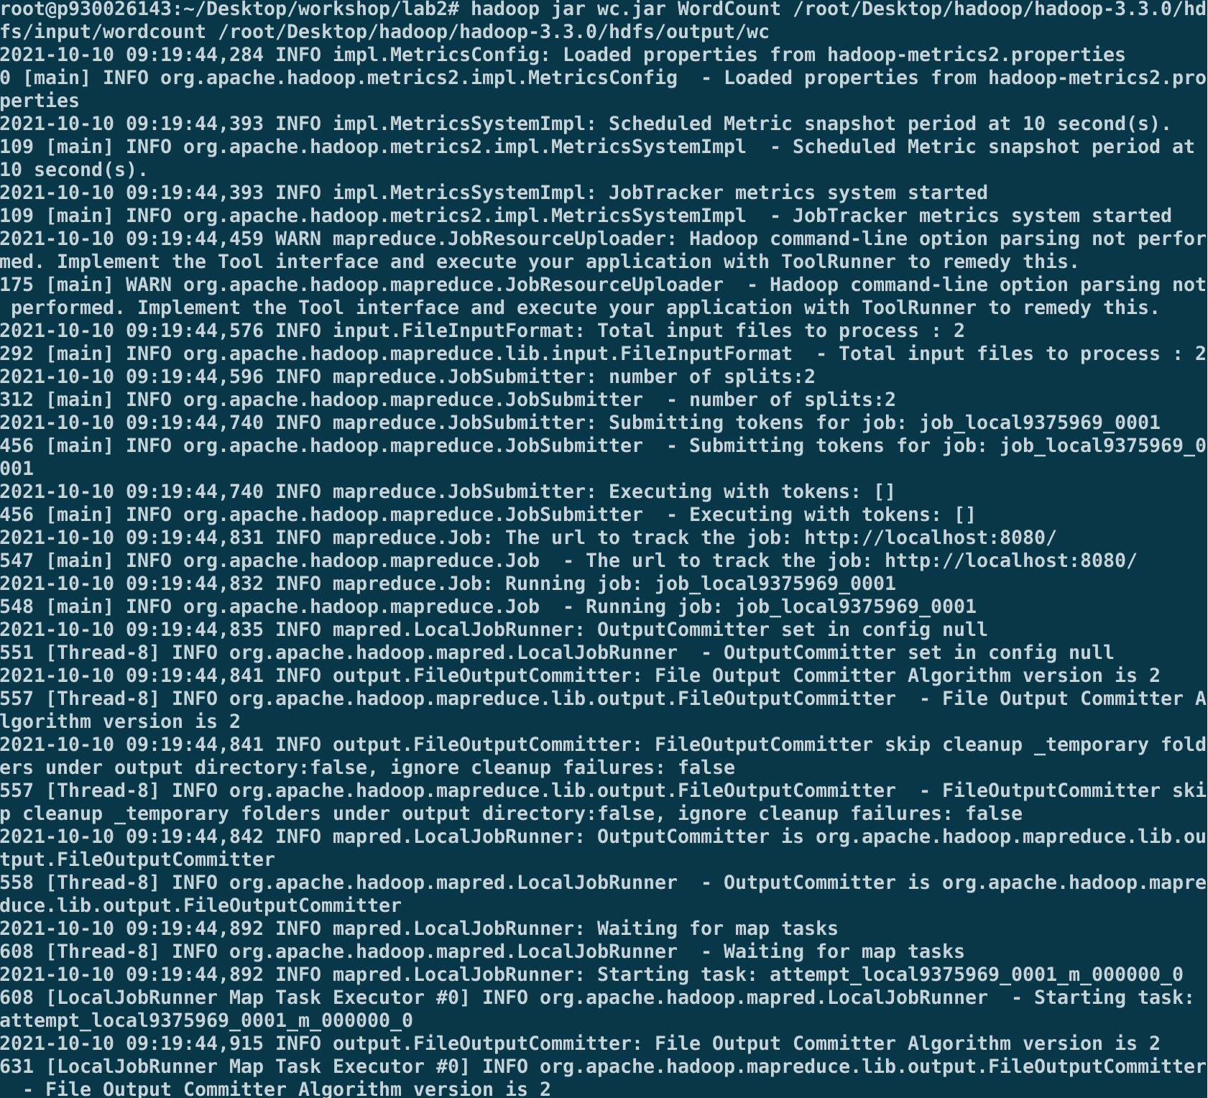

Step 9: Check the output result

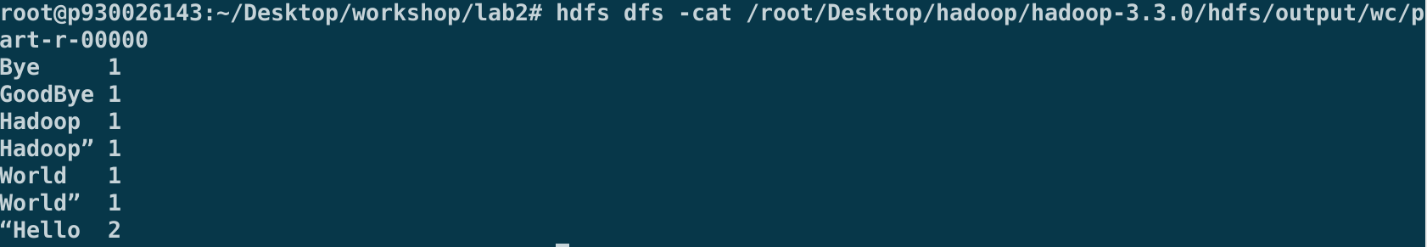

If you can see the result, you have successfully finished part one of lab2.

Step 10: Stop Hadoop

**Part 2: Compile OddEven.java**

Write a Hadoop MapReduce program that counts the number of even and odd

numbers in text files.

Firstly, write a .java file in your home directory and name it “OddEven.java”.

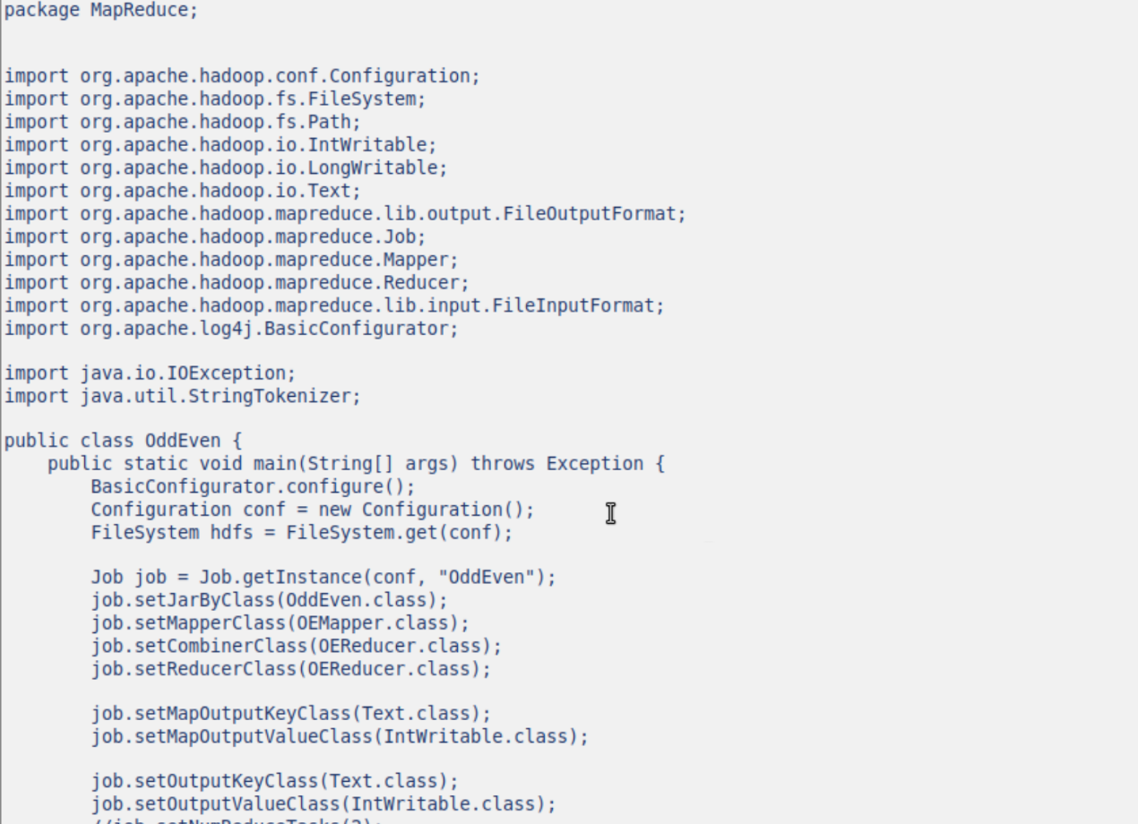

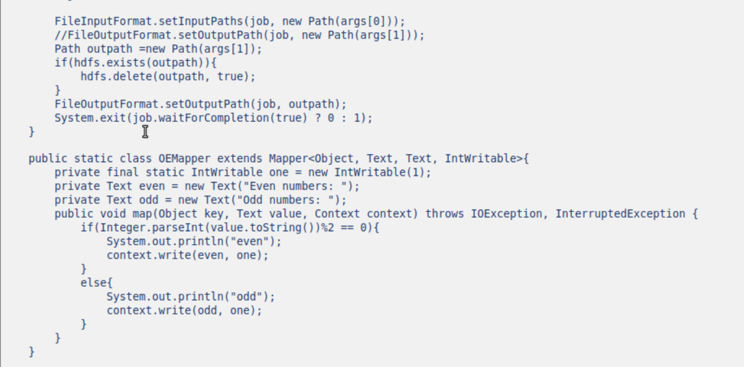

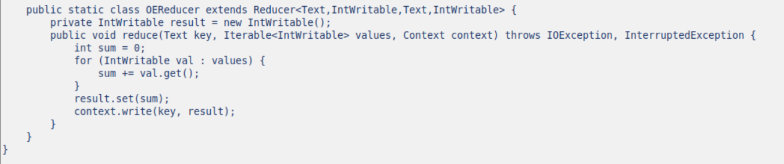

Then type the common:

If you get an error, you should check your file in the HOME path.

Check if it is set correctly. Make sure it has the following four lines:

（The yellow part depends on where you install your Hadoop and java）

-3-3.0

After you finish it, you can type this common to validate the file.

And run the common again:



You can find that there are three more .class files in the folder:

Step 2: Create a jar

Type the following command: You will find oe.jar is created if everything is fine.

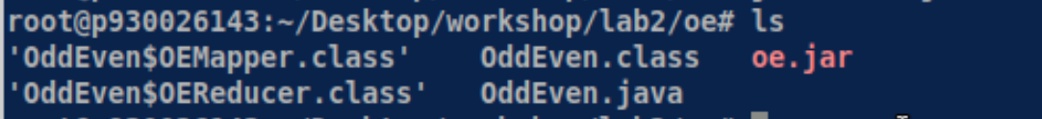

Step 3: create two text files for count odd and even numbers program.

We can use Linux redirect feature to create two text files. You can also use vim to create two text files, for example:

and add some number: 1 3 5 2 4

and add some number: 100 200 300 301 1000

(4 odd numbers and 6 odd numbers in total)

Step 4: Start Hadoop system

$ start-dfs.sh

$ start-yarn.sh



Step 5: Create a subdirectory under input

----

Step 6: Upload file01 and file02 from home directory to hdfs directory:

---

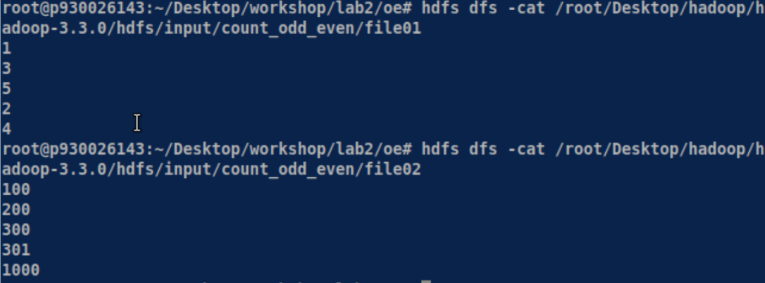

It will get a long message and you should wait about half minutes.

(If you are unfortunate getting the error messages, you should delete your data nodes and create a new one and repeat the steps from step1 to here)

Then you can check the content of file01 and file02

$ --3-3.0

$ --3-3.0/

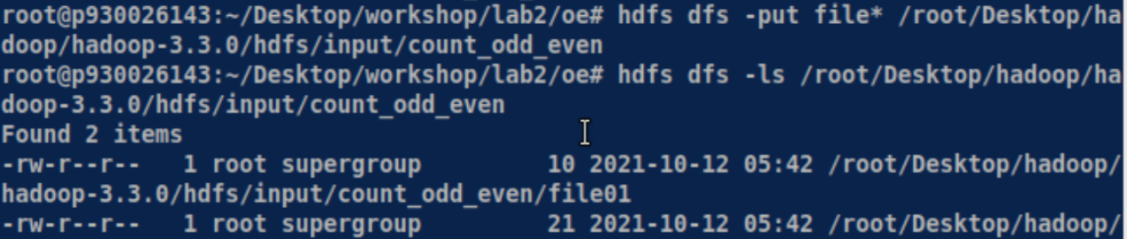

Step 8: Run the application

hadop-3-3.0 -3-3.0

Step 9: Check the output result

-----

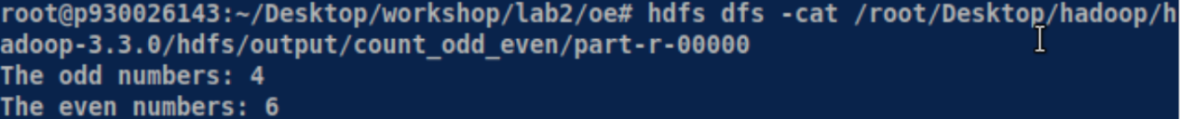

If you can see the result, you have successfully finished part one of lab2. And you can check whether it is correct.

Step 10: Stop Hadoop